**1.SEVERE: Context Initialization Failed**

org.springframework.beans.factory.BeanDefinitionStoreException: IOException parsing XML document from ServletContext resource [/WEB-INF/dispatcher-servlet.xml]; nested exception is java.io.FileNotFoundException: Could not open ServletContext resource [/WEB-INF/dispatcher-servlet.xml]

at org.springframework.beans.factory.xml.XmlBeanDefinitionReader.loadBeanDefinitions(XmlBeanDefinitionReader.java:344)

at org.springframework.beans.factory.xml.XmlBeanDefinitionReader.loadBeanDefinitions(XmlBeanDefinitionReader.java:304)

at

at org.apache.catalina.core.StandardContext.listenerStart(StandardContext.java:4811)

at org.apache.catalina.core.StandardContext.startInternal(StandardContext.java:5251)

at org.apache.catalina.util.LifecycleBase.start(LifecycleBase.java:147)

at org.apache.catalina.core.ContainerBase$StartChild.call(ContainerBase.java:1408)

at org.apache.catalina.core.ContainerBase$StartChild.call(ContainerBase.java:1398)

at java.util.concurrent.FutureTask.run(FutureTask.java:266)

at java.util.concurrent.ThreadPoolExecutor.runWorker(ThreadPoolExecutor.java:1142)

at java.util.concurrent.ThreadPoolExecutor$Worker.run(ThreadPoolExecutor.java:617)

at java.lang.Thread.run(Thread.java:745)

Caused by: java.io.FileNotFoundException: Could not open ServletContext resource [/WEB-INF/dispatcher-servlet.xml]

at

Jul 29, 2016 6:17:17 PM org.apache.coyote.AbstractProtocol start

INFO: Starting ProtocolHandler ["http-nio-8080"]

Jul 29, 2016 6:17:17 PM org.apache.coyote.AbstractProtocol start

INFO: Starting ProtocolHandler ["ajp-nio-8009"]

Jul 29, 2016 6:17:17 PM org.apache.catalina.startup.Catalina start

INFO: Server startup in 2259 ms

**Solution:**

**1.Dispatcher-Servlet Rename**

**2.Verify Dispatcher Servlet Views Folder.**

**3.Once U Verify The Tomcat,Jdk.Before Run As Server We Should Do Clean And Install.**

**2.ERROR CREATE BEAN WITH -SESSION FACTORY ERROR:**

**SOLUTION::Remove The Hibernate Core Dependency From Pom.Xml Do Mavean Clean And Insatall And Again Add The Hibernate Core Dependency To Pom.Xml And Again Do Mavean Clean And Install And Also Do The Project Clean And Run U R Program On Server Then Session Factory Error Has Solved.....**

3.500 ERROR:-

**HTTP Status 500 - Servlet.init() for servlet dispatcher threw exception**

**type** Exception report

**message**Servlet.init() for servlet dispatcher threw exception

**description**The server encountered an internal error that prevented it from fulfilling this request.

**exception**

**Solution:**

You map your dispatcher on *.do:

<servlet-mapping>

<servlet-name>Dispatcher</servlet-name>

<url-pattern>*.do</url-pattern>

</servlet-mapping>

but your controller is mapped on an url without .do:

@RequestMapping("/editPresPage")

Try changing this to:

@RequestMapping("/editPresPage.do")

4. Appears To Have Started A Thread Named

WARNING: The web application [fruitcartweb] appears to have started a thread named [Timer-0] but has failed to stop it. This is very likely to create a memory leak. Stack trace of thread:

java.lang.Object.wait(Native Method)

java.lang.Object.wait(Object.java:502)

java.util.TimerThread.mainLoop(Timer.java:526)

java.util.TimerThread.run(Timer.java:505)

Aug 05, 2016 12:22:51 PM org.apache.coyote.AbstractProtocol start

INFO: Starting ProtocolHandler ["http-nio-8087"]

Aug 05, 2016 12:22:51 PM org.apache.coyote.AbstractProtocol start

INFO: Starting ProtocolHandler ["ajp-nio-8002"]

Aug 05, 2016 12:22:51 PM org.apache.catalina.startup.Catalina start

INFO: Server startup in 16321 ms

**Solution:**

**First connect H2 database.**

5. Exception encountered during context initialization - cancelling refresh attempt: org.springframework.beans.factory.BeanCreationException: Error creating bean with name 'sessionFactory' defined in ServletContext resource [/WEB-INF/application-context.xml]: Initialization of bean failed; nested exception is org.springframework.beans.TypeMismatchException: Failed to convert property value of type [java.util.ArrayList] to required type [java.lang.Class[]] for property 'annotatedClasses'; nested exception is java.lang.IllegalArgumentException: Cannot find class [com.psb.controller.MyController]

Aug 09, 2016 11:23:18 AM org.springframework.web.context.ContextLoader initWebApplicationContext

SEVERE: Context initialization failed

org.springframework.beans.factory.BeanCreationException: Error creating bean with name 'sessionFactory' defined in ServletContext resource [/WEB-INF/application-context.xml]: Initialization of bean failed; nested exception is

**Solution:**

1. My code is compiled on Jdk 1.8.
2. My eclipse, had JDK 1.8 as the compiler.
3. My tomcat in eclipse was using Java 1.7 for its container, hence it was not able to understand the .class files which were compiled using 1.8.
4. To avoid the problem, ensure in your eclipse, double click on your server -> Open Launch configuration -> Classpath -> JRE System Library -> Give the JDK/JRE of the compiled version of java class, in my case, it had to be JDK 1.8
   1. Post this, clean the server, build and redeploy, start the tomcat.

If you are deploying manually into your server, ensure your JAVA_HOME, JDK_HOME points to the correct JDK which you used to compile the project and build the war.

If you do not like to change JAVA_HOME, JDK_HOME, you can always change the JAVA_HOME and JDK_HOME in catalina.bat(for tomcat server) and that'll enable your life to be easy!

6. Compilation error (Build Failure)

[INFO] ------------------------------------------------------------------------

[INFO] Building fruitcart Maven Webapp 0.0.1-SNAPSHOT

[INFO] ------------------------------------------------------------------------

[INFO]

[INFO] --- maven-resources-plugin:2.6:resources (default-resources) @ fruitcartweb ---

[WARNING] Using platform encoding (Cp1252 actually) to copy filtered resources, i.e. build is platform dependent!

[INFO] Copying 0 resource

[INFO]

[INFO] --- maven-compiler-plugin:3.1:compile (default-compile) @ fruitcartweb ---

[INFO] Changes detected - recompiling the module!

[WARNING] File encoding has not been set, using platform encoding Cp1252, i.e. build is platform dependent!

[INFO] Compiling 18 source files to G:\webappworkspace\fruitcartweb\target\classes

[INFO] -------------------------------------------------------------

[WARNING] COMPILATION WARNING :

[INFO] -------------------------------------------------------------

[WARNING] /G:/webappworkspace/fruitcartweb/src/main/java/com/psb/dao/ProductDAOImpl.java: Some input files use or override a deprecated API.

[WARNING] /G:/webappworkspace/fruitcartweb/src/main/java/com/psb/dao/ProductDAOImpl.java: Recompile with -Xlint:deprecation for details.

[INFO] 2 warnings

[INFO] -------------------------------------------------------------

[INFO] -------------------------------------------------------------

[ERROR] COMPILATION ERROR :

[INFO] -------------------------------------------------------------

[ERROR] /G:/webappworkspace/fruitcartweb/src/main/java/com/psb/service/UserService.java:[24,17] non-static variable userDAO cannot be referenced from a static context

[INFO] 1 error

[INFO] -------------------------------------------------------------

[INFO] ------------------------------------------------------------------------

[INFO] BUILD FAILURE

[INFO] ------------------------------------------------------------------------

[INFO] Total time: 3.256 s

[INFO] Finished at: 2016-08-09T11:30:35+05:00

[INFO] Final Memory: 17M/184M

[INFO] ------------------------------------------------------------------------

[ERROR] [Help 1] <http://cwiki.apache.org/confluence/display/MAVEN/MojoFailureException>

Solution:-

**There is a compile error that occurred earlier during the build. Look for that error in the same output log file and try to fix it**

7. 11/08/2016

Aug 11, 2016 5:51:31 PM org.apache.tomcat.util.digester.SetPropertiesRule begin

WARNING: [SetPropertiesRule]{Server/Service/Engine/Host/Context} Setting property 'source' to 'org.eclipse.jst.j2ee.server:fruitcartweb' did not find a matching property.

Aug 11, 2016 5:51:31 PM org.apache.catalina.startup.VersionLoggerListener log

INFO: Server version: Apache Tomcat/8.0.33

Aug 11, 2016 5:51:31 PM org.apache.catalina.startup.VersionLoggerListener log

Aug 11, 2016 5:51:31 PM org.apache.catalina.startup.VersionLoggerListener log

INFO: OS Name: Windows 8

Solution:-

**The solution to this problem is very simple. Double click on your tomcat server. It will open the server configuration. Under server options check ‘Publish module contents to separate XML files’ checkbox. Restart your server. This time your page will come without any issues.**

8.**[Setpropertiesrule]{Server/Service/Engine/Host/Context} Setting Property 'Source' To 'Org.Eclipse.Jst.J2ee.Server:Fruitcartweb' Did Not Find A Matching Property.**

**Solution: The Solution To This Problem Is Very Simple. Double Click On Your Tomcat Server. It Will Open The Server Configuration. Under Server Options Check ‘Publish Module Contents To Separate Xml Files’ Checkbox. Restart Your Server. This Time Your Page Will Come Without Any Issues.**

**9.SEVERE: Allocate exception for servlet dispatcher**

solution:-

in controller we need give proper mapping (jsp file name,form action)

**10.[Setpropertiesrule]{Server/Service/Engine/Host/Context} Setting Property 'Source' To 'Org.Eclipse.Jst.J2ee.Server:Fruitcartweb' Did Not Find A Matching Property.**

**SOLUTION:** Apply The Security Dependeies Like Core ,Web,Config Proper Versions.

11.[SetPropertiesRule]{Server/Service/Engine/Host/Context} Setting property 'source' to 'org.eclipse.jst.j2ee.server:fruitcartweb' did not find a matching property

SOLUTION:-Once drop table in h2 data base,then u should create the table.

12.ERROR:-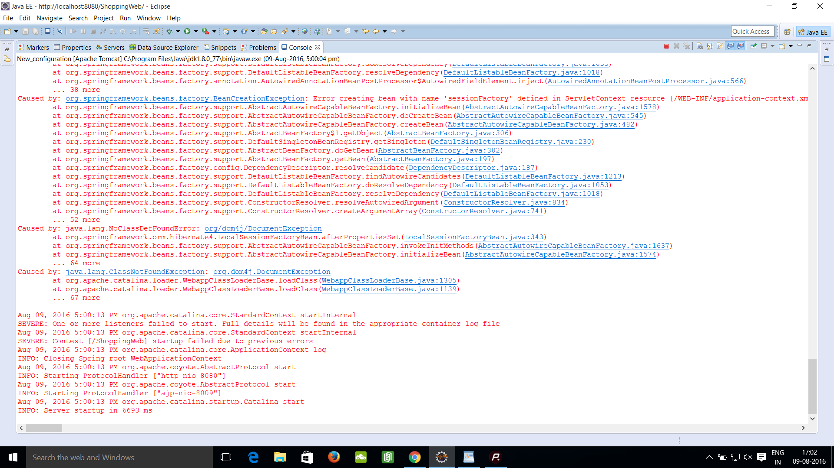

**SOLUTION:- To overcome with dom4j error we can download dom4j 1.6 dependency from mvn repository**

**Note:- Avoid adding dom4j 1.6.1.**

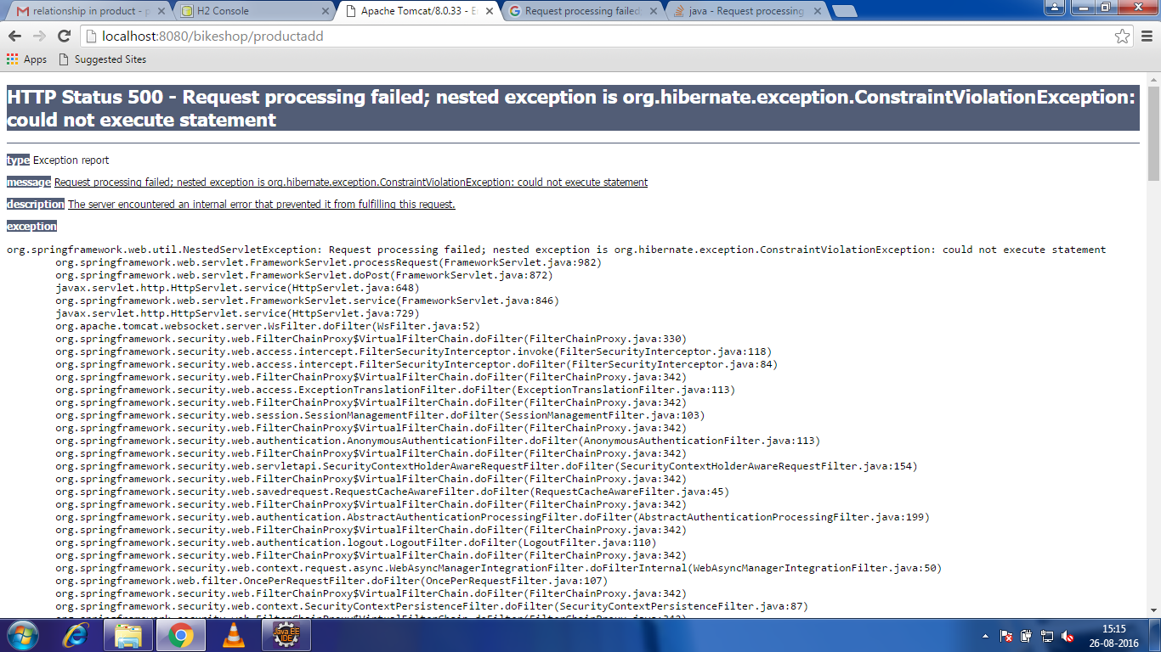

**Solution:**